Unit-wise Notes

Course Code : 417523
Course Name : Elective – III Quantum Artificial Intelligence
Semester : I

Course Objectives:
- To get acquainted with the principles of quantum computing and the usage of Linear
algebra in Quantum Computing
- To understand the Architecture of Quantum computing and solve examples of Quantum Fourier Transforms
- To understand the concepts of basic and advanced Quantum Algorithms and apply them to various problems.
- To study quantum machine learning and apply these to develop hybrid solutions
- To study the Quantum Theory with Fault-Tolerant Quantum techniques
- To understand Problem-Solving using various peculiar search strategies for AI

Course Outcomes:

CO1: Understand quantum requirements and formulate design solutions using quantum circuits.
CO2: Illustrate applicable solutions in one or more application domains using a quantum
architecture that integrates ethical, social, and legal concerns
CO3: Apply the Advanced Quantum Algorithms on real time problem
CO4: Analyze the quantum machine learning algorithms and their relevant application
CO5: Analyze quantum information processing & its relevant algorithms
CO6: Evaluate suitable algorithms for AI problems

Unit 2 Quantum Architecture

Quantum computers
Quantum computers are designed to perform tasks much more accurately and efficiently than conventional computers, providing developers with a new tool for specific applications.
It is clear in the short-term that quantum computers will not replace their traditional counterparts; instead, they will require classical computers to support their specialized abilities, such as systems optimization.

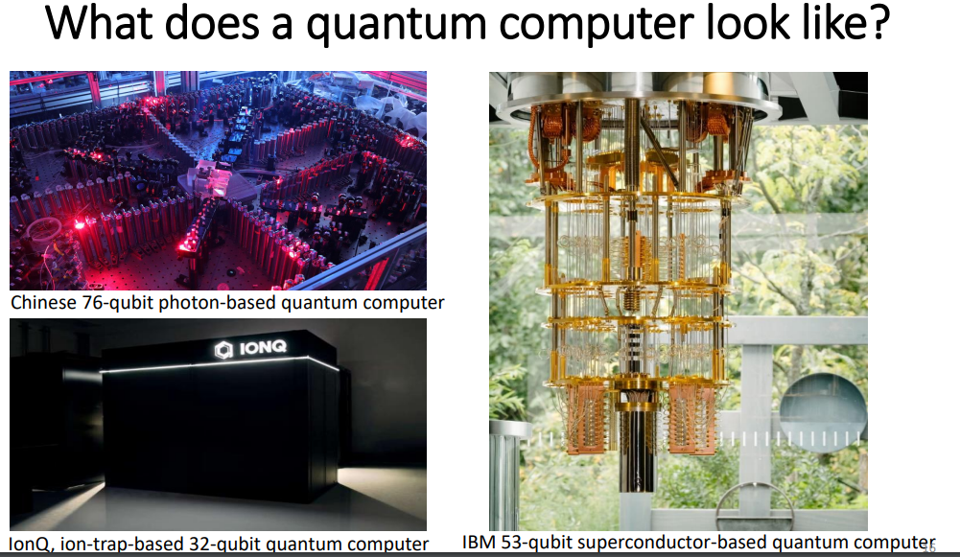

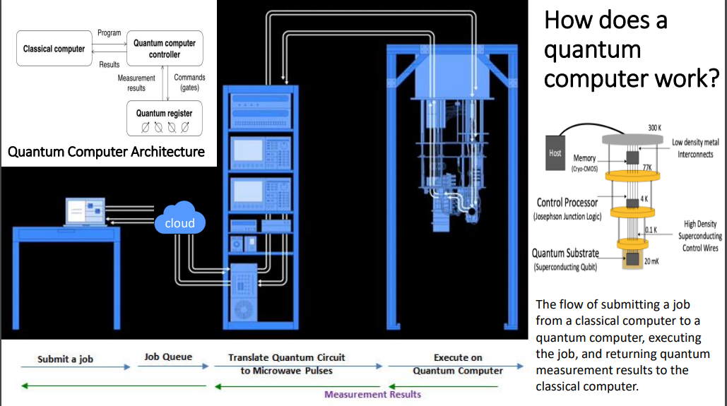

The Framework of Quantum Mechanics :
Quantum mechanics is a fundamental theory in physics that describes the behavior of matter and energy at the atomic and subatomic scales. It provides a framework for understanding the behavior of particles, waves, and interactions at the quantum level. The theory was developed in the early 20th century and has been tremendously successful in explaining a wide range of phenomena, from the behavior of electrons in atoms to the properties of exotic particles in high-energy physics.

The framework of quantum mechanics can be summarized by several key principles and mathematical formalisms:

Wave-particle duality: One of the fundamental principles of quantum mechanics is the wave-particle duality. It states that elementary particles, such as electrons and photons, exhibit both wave-like and particle-like behavior. Depending on the experimental setup, they can behave as discrete particles or as waves with wave-like properties, such as interference and diffraction.

Superposition: Quantum systems can exist in a state of superposition, meaning they can simultaneously be in multiple states with different probabilities. For example, an electron can be in a superposition of multiple positions or energy states until a measurement is made, causing the system to collapse into one specific state.

Quantum States and Wavefunctions: Quantum states are represented by wavefunctions, often denoted by the Greek letter "psi" (Ψ). The wavefunction contains all the information about the quantum system and is used to calculate the probabilities of different outcomes upon measurement.

Measurement and Collapse of the Wavefunction: When a measurement is made on a quantum system, it causes the wavefunction to "collapse" to one of its possible states, and the outcome of the measurement is probabilistic. The famous Schrödinger's cat thought experiment illustrates this concept.

Uncertainty Principle: Quantum mechanics introduces the uncertainty principle, formulated by Werner Heisenberg. It states that certain pairs of complementary properties, such as position and momentum, cannot be simultaneously measured with arbitrary precision. The more accurately you measure one property, the less accurately you can know the other.

Quantum Operators and Observables: Physical quantities in quantum mechanics are represented by mathematical operators. For example, the position of a particle is represented by the position operator, and the momentum is represented by the momentum operator. Observables are properties that can be measured and correspond to the eigenvalues of the corresponding operators.

Schrödinger Equation: The time evolution of a quantum system is governed by the Schrödinger equation, a partial differential equation that describes how the wavefunction changes over time. This equation determines the probability distribution of possible outcomes.

Quantum Entanglement: Quantum entanglement is a phenomenon where two or more particles become correlated in such a way that the state of one particle cannot be described independently of the other particles' states. It plays a crucial role in quantum information and quantum computing.

The framework of quantum mechanics is incredibly successful in explaining a wide range of phenomena, but it also introduces some counterintuitive concepts that challenge classical intuitions. Despite its success, quantum mechanics is not yet fully integrated with general relativity, the theory of gravity, and efforts to unify these two fundamental theories continue in the field of theoretical physics.
The State of a Quantum System
The state of a quantum system is a fundamental concept in quantum mechanics that describes the complete information about the system at a given time. It is represented by a mathematical object called the wave function (ψ) or state vector. The state vector contains all the information about the probabilities of different outcomes that can be observed when measuring physical properties of the system.
The state of a quantum system can be represented in a few different ways, depending on the context and the type of system being considered:
Wave Function (ψ): In the context of non-relativistic quantum mechanics, the state of a single particle is often described by a complex-valued function called the wave function (ψ). The square of the absolute value of the wave function (|ψ|^2) represents the probability density of finding the particle at a particular location in space. The wave function evolves over time according to the Schrödinger equation.
Ket Notation (|ψ⟩): In the formalism of quantum mechanics, the state of a quantum system can be represented using ket notation, which is part of the bra-ket notation introduced by Paul Dirac. For a system with a state vector represented by |ψ⟩, the probability of obtaining a particular measurement outcome (an observable) is given by the inner product of the state vector with the eigenvector corresponding to that outcome.
Density Matrix (ρ): For more complex quantum systems, such as mixed states (ensembles of quantum states with different probabilities), the state of the system may be described using a density matrix (ρ). The density matrix provides a more general representation of quantum states and can describe both pure states (represented by rank-one density matrices) and mixed states.

Quantum State Vectors and Hilbert Space: The state of a quantum system exists in a mathematical space called the Hilbert space, which is a complex vector space with certain mathematical properties. The dimension of the Hilbert space depends on the number of degrees of freedom of the system. It is important to note that the state of a quantum system is not always deterministic; instead, it is associated with probabilities. Upon measurement, the system collapses into one of its possible states, and the outcome is probabilistic. This probabilistic nature is a key feature of quantum mechanics and sets it apart from classical physics, where states are deterministic.
The Time Evolution of a closed system :
In quantum artificial intelligence (AI), the concept of time evolution of a closed quantum system is closely related to quantum mechanics and its application in solving problems using quantum computers. Quantum mechanics describes the behavior of particles at the quantum level, and quantum computers leverage these principles to perform certain types of calculations more efficiently than classical computers.
The time evolution of a closed quantum system is described by the Schrödinger equation, which governs how the state of a quantum system changes over time. The Schrödinger equation for a closed quantum system is given by:
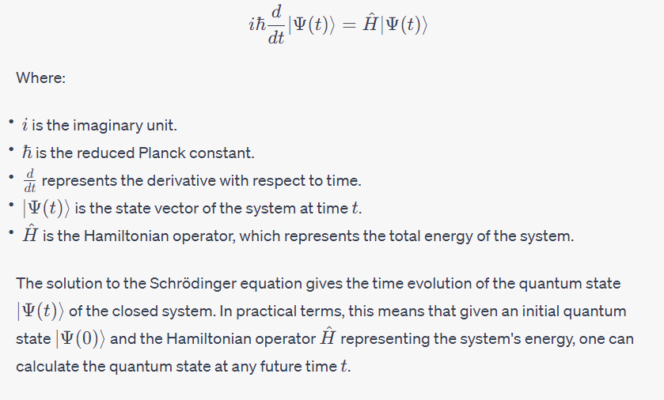
In the context of quantum AI, quantum computers can potentially exploit the principles of quantum superposition and entanglement to solve certain problems more efficiently than classical computers. These problems include optimization, cryptography, and simulations of quantum systems.
For example, a closed quantum system might be a molecule that is difficult to simulate classically due to the complexity of its quantum interactions. Quantum computers can be used to simulate the time evolution of such molecules, potentially enabling advancements in fields like material science and drug discovery. It's important to note that quantum systems are susceptible to decoherence and noise from their environment, which can introduce errors in the time evolution calculations. Quantum error correction techniques are being developed to address these challenges and ensure the reliability of quantum computations.
The time evolution of a closed quantum system in the context of quantum AI is governed by the Schrödinger equation, which describes how the quantum state changes over time based on the system's Hamiltonian operator. Quantum computers leverage this concept to solve certain problems more efficiently, but they also face challenges related to decoherence and noise. The time-evolution of a closed quantum system is relevant in quantum AI and some key considerations:
Quantum Algorithms and Simulation: Quantum algorithms, like the Quantum Phase Estimation algorithm or the Variational Quantum Eigensolver, exploit the time-evolution of quantum systems to solve certain problems more efficiently than classical algorithms. These algorithms involve simulating the evolution of a quantum system over time to extract useful information.
Hamiltonian Evolution: In quantum mechanics, the evolution of a closed quantum system is governed by the Schrödinger equation, which describes how the state of the system changes over time based on the system's Hamiltonian operator. Quantum algorithms leverage this concept to perform tasks such as simulating quantum systems, solving optimization problems, or estimating eigenvalues.
Adiabatic Quantum Computing: Adiabatic quantum computing is a quantum algorithmic approach that involves slowly changing the Hamiltonian of a quantum system from an initial state to a final state, with the hope that the system remains in its ground state throughout the process. This concept is related to the time-evolution of the Hamiltonian.
Proof through Quantum Simulators: Quantum simulators are a type of quantum computer that can simulate the behavior of other quantum systems. Researchers can use these simulators to demonstrate and validate the time-evolution of quantum systems for specific problems.
Physical Experiments: While not a "proof" in the mathematical sense, physical experiments can provide evidence for the time-evolution of closed quantum systems. Quantum AI researchers can design experiments that involve quantum systems and showcase their behavior over time, supporting the theoretical concepts.
Quantum systems are complex and can be challenging to simulate and analyze, especially as they grow in size. While the fundamental principles of quantum mechanics provide a strong foundation, practical implementations can involve approximations and numerical techniques to understand the behavior of closed quantum systems.
The Schrödinger equation essentially states that the change in the quantum state (Ψ) with respect to time is proportional to the application of the Hamiltonian operator (H^) on that state. The Hamiltonian operator consists of the kinetic energy and potential energy operators of the system.
The Schrödinger equation has both time-dependent and time-independent solutions:
- Time-Dependent Solution: Solving the time-dependent Schrödinger equation yields the wave function Ψ(r,t), which describes the probability amplitude of finding a particle at a particular position r and time t.
- Time-Independent Solution: By assuming a separation of variables, one can find solutions for the energy eigenstates and their corresponding energy eigenvalues. These solutions are stationary states and describe the long-term behavior of the system.
The Schrödinger equation plays a central role in understanding the behavior of quantum systems, such as electrons in atoms, molecules, and other subatomic particles. It governs phenomena like particle-wave duality, quantum tunneling, and quantum interference.
It's important to note that while the Schrödinger equation provides a foundational description of quantum systems, it doesn't address all aspects of quantum mechanics. In particular, it's a non-relativistic equation and doesn't account for relativistic effects, which become important for particles moving at significant fractions of the speed of light. For these cases, relativistic quantum mechanics, as described by the Dirac equation, is used.
Composite Systems :

In quantum mechanics, a composite system refers to a system that is composed of two or more individual subsystems, each of which can have its own quantum states and dynamics. Understanding composite systems is crucial for describing interactions and correlations between multiple quantum entities. This concept is particularly relevant in quantum computing and quantum information theory.

Composite systems play a central role in quantum architecture, from quantum computing to quantum communication. Understanding how subsystems interact, become entangled, and are manipulated is essential for designing and implementing quantum algorithms and protocols.

Here are some key points about composite systems in quantum architecture:

- Tensor Product Space: When dealing with composite systems, the Hilbert space (a complex vector space that describes the quantum states) of the composite system is the tensor product of the Hilbert spaces of the individual subsystems. Mathematically, if subsystem A lives in a Hilbert space H_A and subsystem B lives in a Hilbert space H_B, then the composite system AB lives in the Hilbert space H_A ⊗ H_B.

- Quantum States: The quantum state of a composite system is described by a state vector that lives in the tensor product space. If |a> is a state of subsystem A and |b> is a state of subsystem B, then the joint state of the composite system is |a> ⊗ |b>.

- Entanglement:

- One of the most intriguing aspects of quantum composite systems is entanglement.

- Entanglement refers to a situation where the quantum state of the composite system cannot be factored into individual states for the subsystems. Entangled states exhibit strong correlations that cannot be explained by classical physics and have applications in quantum communication, cryptography, and quantum algorithms.

- When a pair or group of particles is generated, interact, or share spatial proximity in a way such that the quantum state of each particle of the pair or group cannot be described independently of the state of the others, even when the particles are separated by a large distance.
- An entangled pair is a single quantum system in a superposition of equally possible states. The entangled state contains no information about the individual particles, only that they are in opposite states.
- If the state of one is changed, the state of the other is instantly adjusted
- to be consistent with quantum mechanical rules.
- If a measurement is made on one, the other will automatically collapse.

Quantum entanglement is at the heart of the disparity between classical and quantum physics:

entanglement is a primary feature of quantum mechanics lacking in classical mechanics.
Entanglement is a joint characteristic of two or more quantum particles.
Einstein called it “spooky actions at a distance”

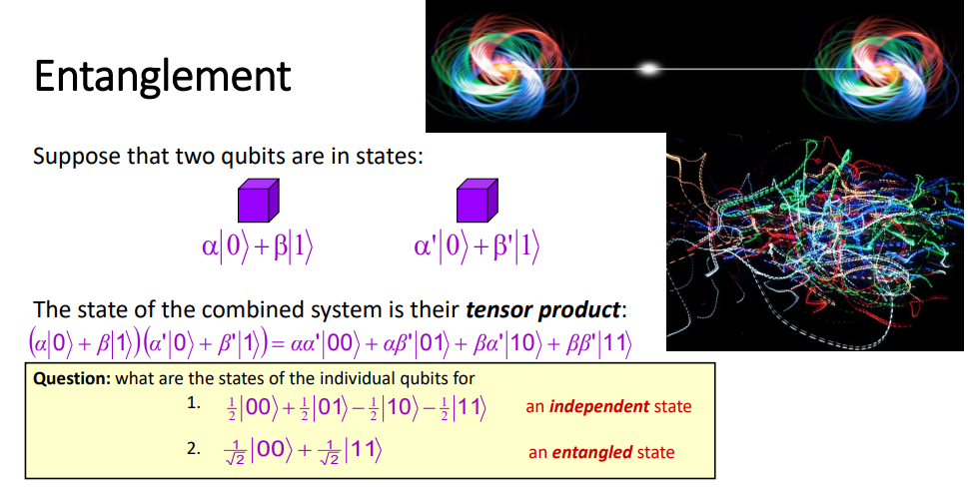

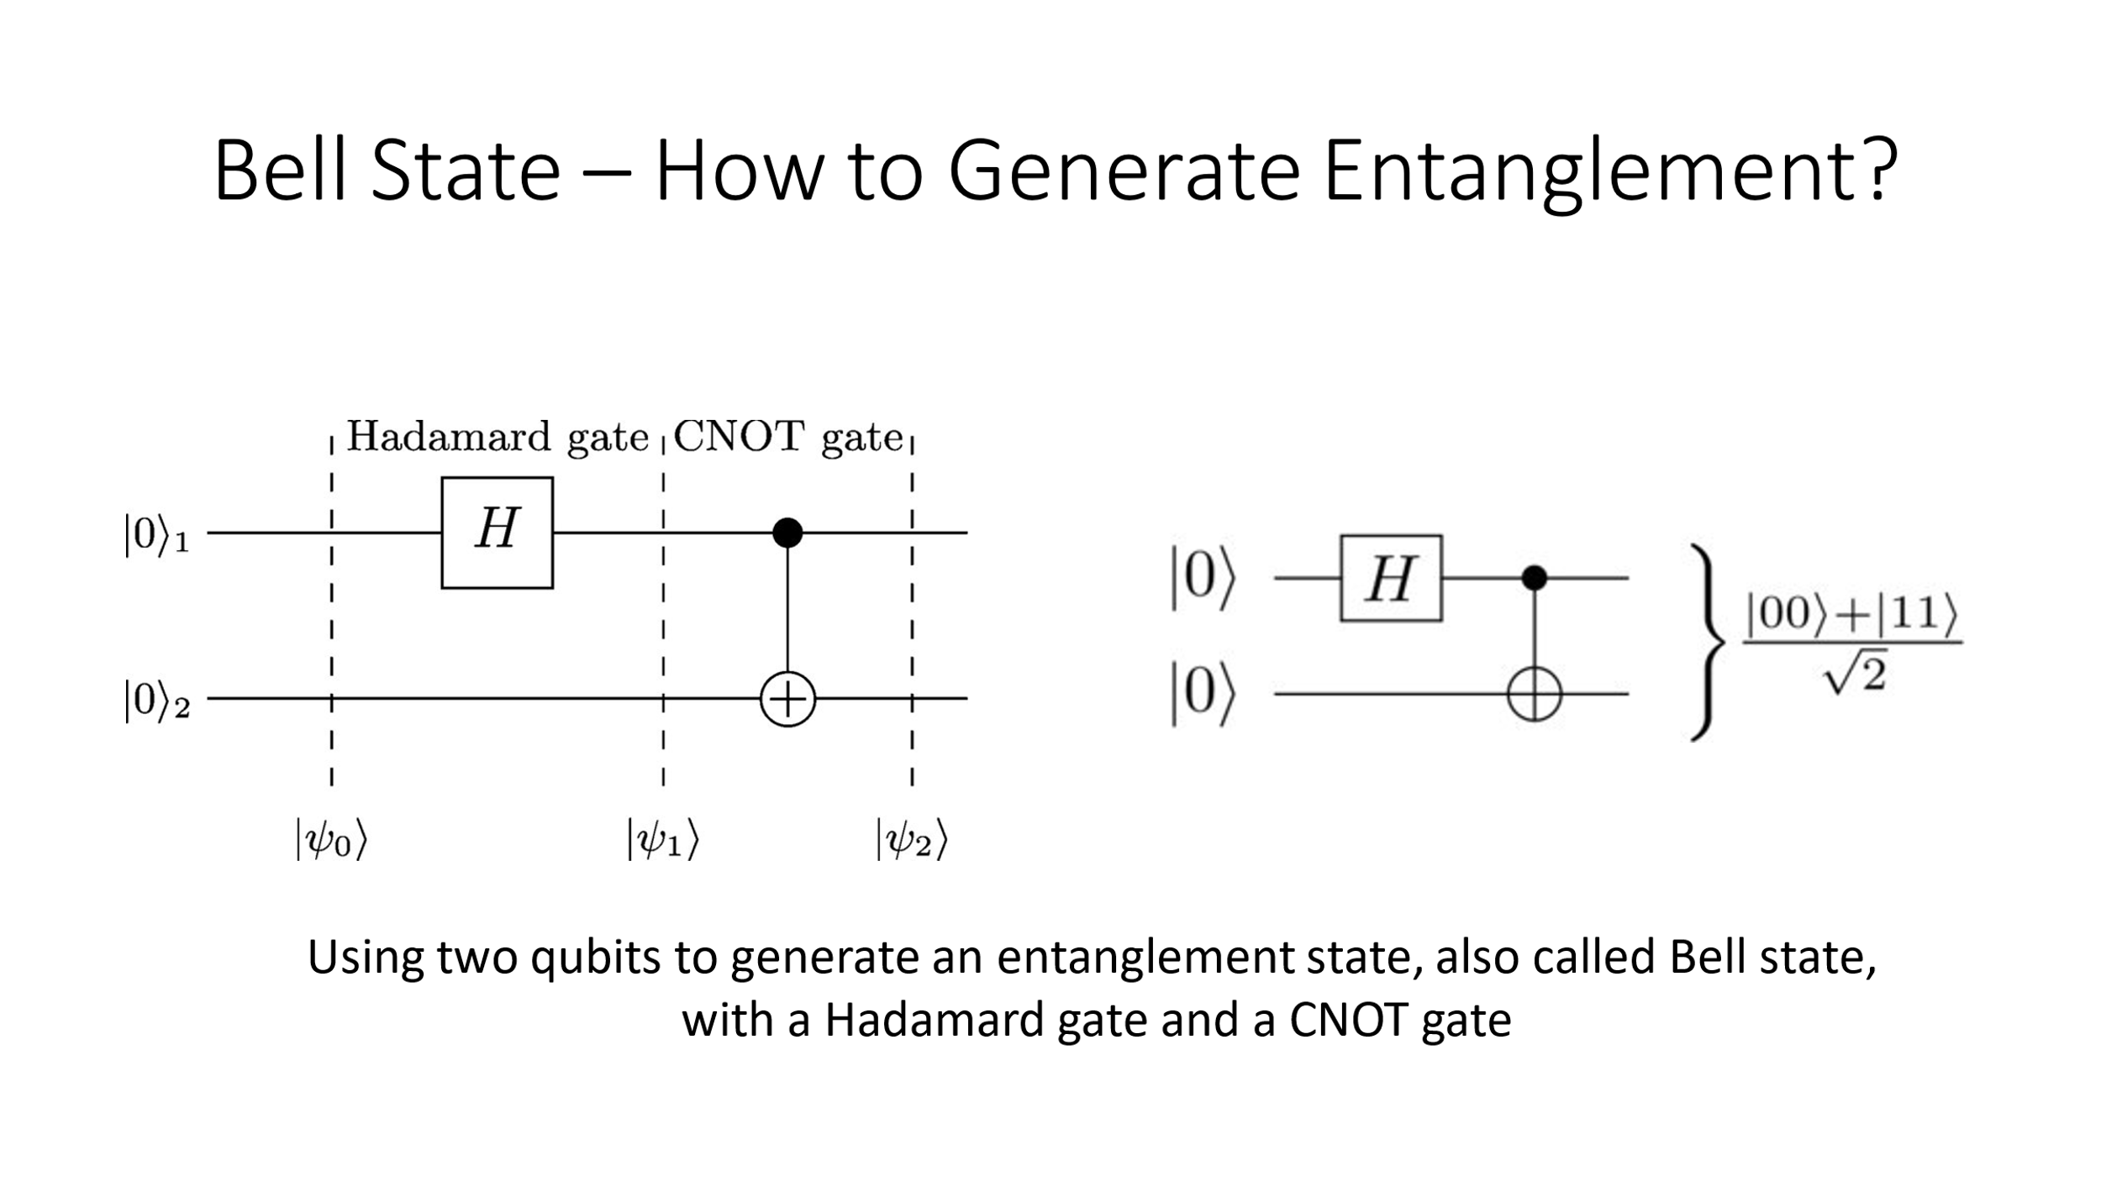
- Operations and Gates: In quantum computing, operations on composite systems are represented by unitary operators acting on the tensor product space. For example, if you want to perform an operation on subsystem A and leave subsystem B unchanged, you would use a unitary operator that acts as the identity on B and performs the desired operation on A.

- Quantum Algorithms:

- Many quantum algorithms leverage the capabilities of composite systems.
- For example, Shor's algorithm for factoring large numbers and Grover's algorithm for searching an unsorted database both operate on composite systems to achieve exponential speedup compared to classical counterparts.
- It may be possible to solve a problem on a quantum system much faster than on a classical computer
- Factoring and searching are examples of problems where quantum algorithms are known and are faster than any classical ones, Implications for cryptography, information security
- Quantum Gates:
- Quantum gates for composite systems are constructed using tensor products of single-qubit gates (for qubits) or
- single-qudit gates (for qudits, which are quantum systems with more than two levels).
- Controlled gates, which involve interactions between subsystems, are also fundamental building blocks for constructing quantum circuits.
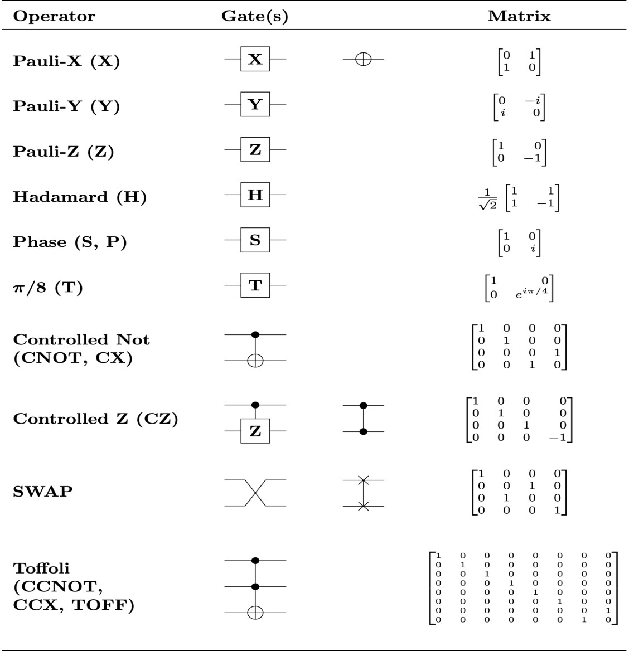

- Quantum Error Correction: In quantum computing, error correction codes are often employed to protect quantum information from decoherence and errors. These codes often involve encoding information across multiple subsystems to detect and correct errors.

- Quantum Entanglement Gates: In some quantum architectures, entangling gates are used to create and manipulate entanglement between subsystems. These gates are crucial for building quantum circuits that perform specific tasks and computations.

Composite systems play a central role in quantum architecture, from quantum computing to quantum communication. Understanding how subsystems interact, become entangled, and are manipulated is essential for designing and implementing quantum algorithms and protocols.

Mixed States:

In quantum mechanics, pure states represent the most idealized and well-defined quantum states. However, in many real-world scenarios, quantum systems are subject to noise and interactions with their environment, leading to a loss of coherence and a mixture of quantum states. These mixed states cannot be represented by a single state vector in the Hilbert space but are described by density matrices.

A density matrix ρ is a Hermitian, positive semi-definite matrix that captures both the probabilities and the coherence of different quantum states within a mixed ensemble. For a pure state |ψ⟩, the corresponding density matrix is given by ρ = |ψ⟩⟨ψ|. Mixed states play a crucial role in modeling noise, errors, and uncertainty in quantum systems, which are especially important in quantum computing.

Ensembles – Pure state and mixed states -

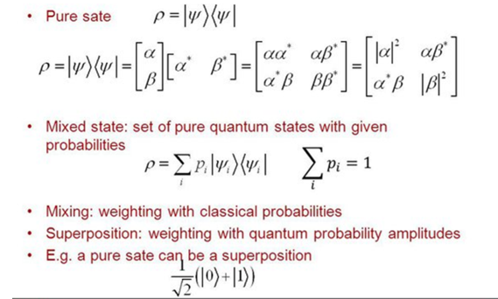

General quantum operations:
General quantum operations, often referred to as quantum channels, describe the evolution of quantum states in the presence of noise and interactions with the environment.
These operations encompass a wide range of transformations that can occur on a quantum system, including unitary transformations, measurement processes, and more general non-unitary processes.
Quantum channels are typically described by a linear, completely positive, and trace-preserving (CPTP) map that takes a density matrix as input and produces another density matrix as output.
They model various phenomena like decoherence, relaxation, and measurement effects. Quantum error correction and fault tolerance strategies in quantum computing rely on the understanding and manipulation of these operations.
Unitary transformations
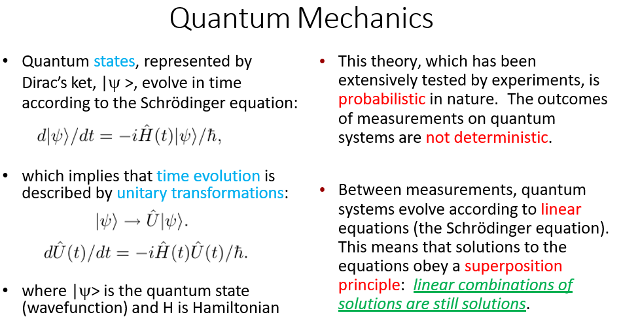

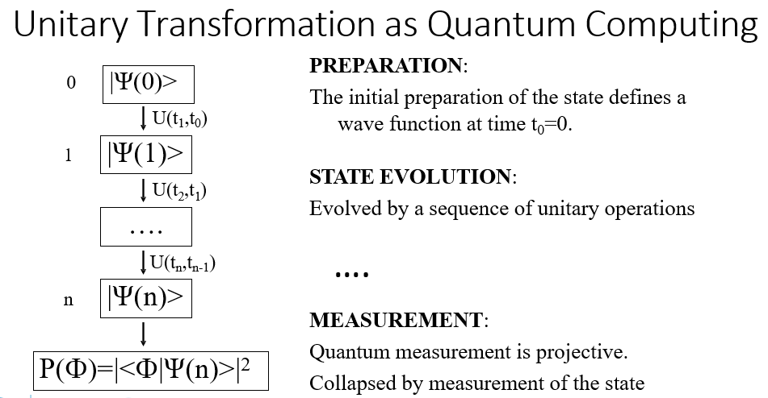

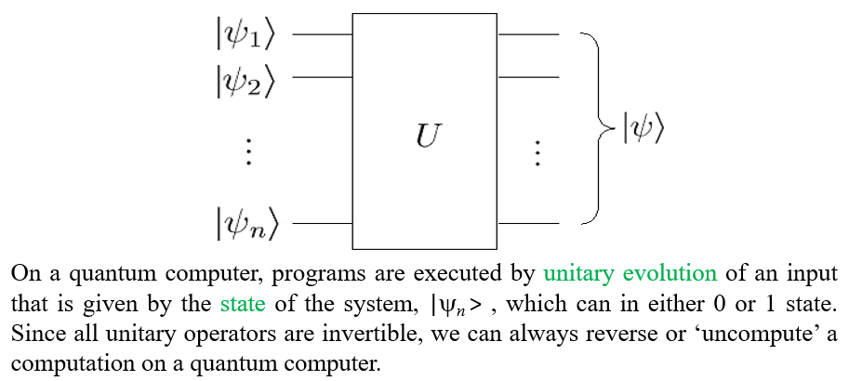

Measurements:
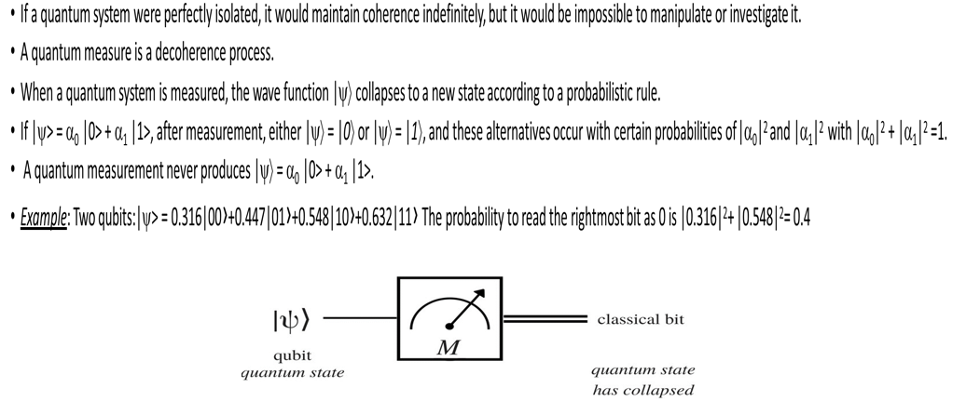

Universal Sets of Quantum Gates :
A universal set of quantum gates is a set of gates that, when combined, can approximate any quantum operation.
These sets are foundational for constructing quantum computers and implementing quantum algorithms. The choice of the universal set depends on the underlying qubit or qudit architecture and the specific requirements of the quantum computation.

There are two main types of universal sets: sets based on qubits and sets based on qudits (quantum systems with more than two levels).

Universal Sets for Qubits:

a. Single-Qubit Gates: A universal set can be constructed using a single-qubit Hadamard gate (H) and two distinct single-qubit gates, usually chosen as the Pauli-X gate (X) and the Pauli-Z gate (Z). The Hadamard gate generates superposition states, and the Pauli-X and Pauli-Z gates provide the necessary rotations to approximate any unitary transformation on a single qubit.

b. Two-Qubit Entangling Gate: In addition to the single-qubit gates, a two-qubit entangling gate is needed. The most common choice is the controlled-NOT gate (CNOT), which is a controlled-X gate.

Universal Sets for Qudits:

Universal sets for qudits (quantum systems with d levels, where d > 2) can be constructed similarly, using generalizations of single-qubit gates and two-qudit entangling gates.

a. Single-Qudit Gates: For qudits, single-qudit gates that generate superposition states and phase shifts are used. These gates are often based on the discrete Fourier transform, which is analogous to the Hadamard gate for qubits.

b. Two-Qudit Entangling Gate: The two-qudit equivalent of the CNOT gate is required. In some cases, multi-controlled gates are used to create entanglement among qudits.

The choice of the universal set depends on the specific quantum computing architecture and the physical properties of the qubits or qudits being used. Various physical implementations of qubits, such as superconducting qubits, trapped ions, and topological qubits, may have different optimal choices for the universal set.

It's important to note that while a universal set of gates allows for the implementation of any quantum operation, the efficiency of quantum algorithms and error correction can be affected by the specific gate set used. Certain gate sets might be more naturally suited for certain algorithms or may exhibit better fault-tolerance properties.

Quantum Measurement:
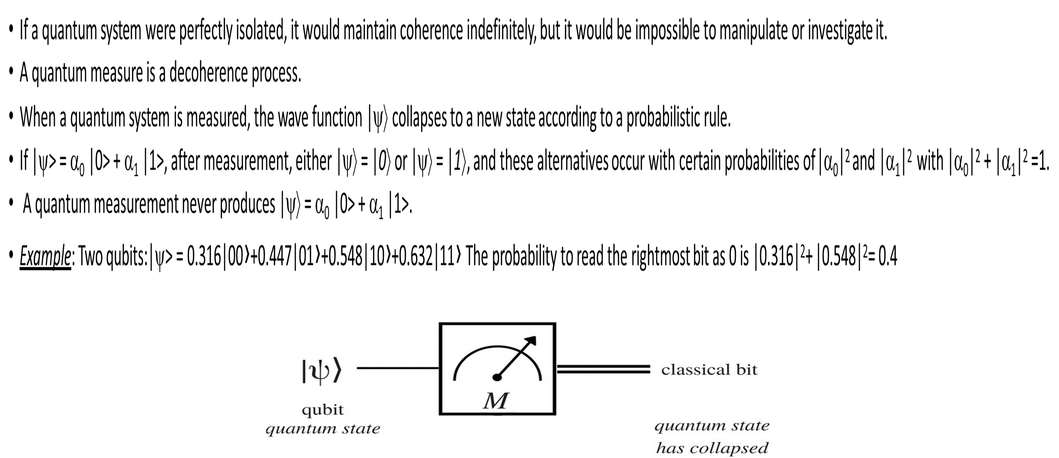

Quantum Entanglement :
- Entanglement refers to a situation where the quantum state of the composite system cannot be factored into individual states for the subsystems.
- When a pair or group of particles is generated, interact, or share spatial proximity in a way such that the quantum state of each particle of the pair or group cannot be described independently of the state of the others, even when the particles are separated by a large distance.
- An entangled pair is a single quantum system in a superposition of equally possible states. The entangled state contains no information about the individual particles, only that they are in opposite states.
- If the state of one is changed, the state of the other is instantly adjusted to be consistent with quantum mechanical rules.
- If a measurement is made on one, the other will automatically collapse.

The Quantum Fourier transform and its Applications-
The Quantum Fourier transform (QFT) :

The Fourier transform occurs in many different versions throughout classical computing, in areas ranging from signal processing to data compression to complexity theory. The quantum Fourier transform (QFT) is the quantum implementation of the discrete Fourier transform over the amplitudes of a wavefunction. It is part of many quantum algorithms, most notably Shor's factoring algorithm and quantum phase estimation.
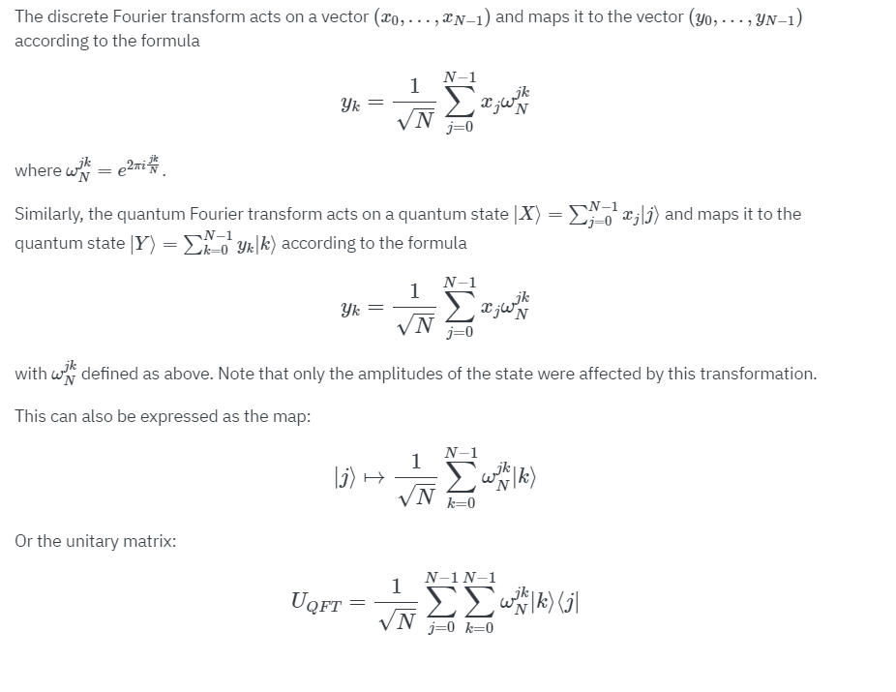

In simple terms, the QFT essentially transforms the phases of the basis states in a way that encodes the frequency information of the input state. This transformation is achieved by performing a sequence of Hadamard gates and controlled-phase rotations on the qubits of the input state.

The QFT has several important properties:
1. Superposition: The QFT maps an input state to a superposition of states with different frequency components.
2. Quantum Parallelism: The QFT can simultaneously evaluate multiple frequency components in parallel, making it potentially faster for certain tasks compared to classical algorithms.
3. Interference: Interference between different frequency components occurs in the QFT, which can lead to constructive or destructive interference depending on the phases.

The QFT illustrates the power of quantum computation in efficiently solving problems that involve the analysis of periodic or repetitive patterns.

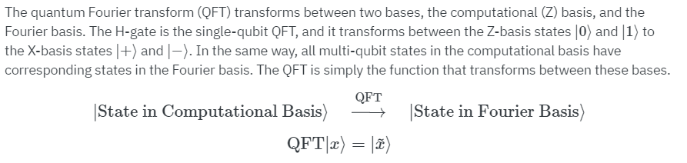

The QFT illustrates the power of quantum computation in efficiently solving problems that involve the analysis of periodic or repetitive patterns. While it's a fundamental tool, implementing the QFT can be complex due to the need for precise phase manipulations and managing qubit entanglement.



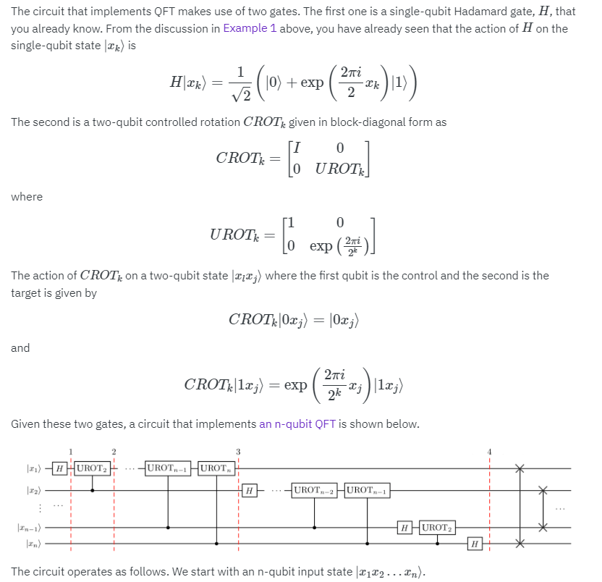

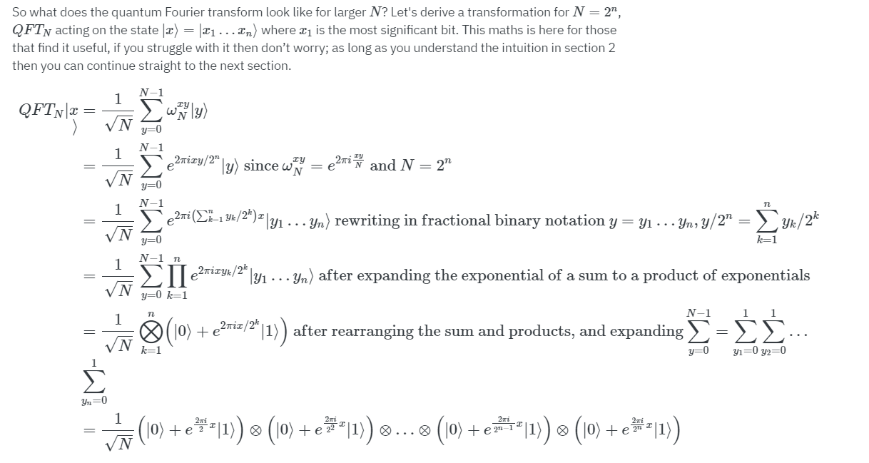

Phase estimation :
Phase estimation is a powerful technique that harnesses quantum parallelism and the Quantum Fourier Transform to extract valuable information about the phases of quantum states, enabling the solution of problems that are classically hard to solve efficiently.
Phase estimation in the context of the Quantum Fourier Transform involves determining the phase of a quantum state relative to a reference state. This phase information is essential for extracting frequency or eigenvalue information from quantum states.
Here's how phase estimation works within the Quantum Fourier Transform:
- Setup: Phase estimation involves two quantum registers: the control register (often referred to as the "target" register) and the eigenstate register. The control register is used to prepare an eigenstate of the unitary operator whose phase we want to estimate, while the eigenstate register is used to estimate the phase.
- Initial State: The control register is prepared in a superposition of eigenstates of the unitary operator, and the eigenstate register is initialized to a known state (usually ∣0⟩∣0⟩n, where n is the number of qubits in the register).
- Phase Kickback: The key step in phase estimation is the application of a controlled unitary operation. This controlled unitary operator is often chosen such that it introduces a phase factor to the eigenstate in the eigenstate register, depending on the eigenvalue we want to estimate. This phase information is "kicked back" to the control register due to the controlled operation.
- Inverse QFT: After the phase kickback, the Quantum Fourier Transform is applied to the eigenstate register. The Quantum Fourier Transform maps the phases of the eigenstates in the eigenstate register into amplitudes, revealing the phase information in a format that is more easily measurable.
- Measurement: Finally, a measurement is performed on the eigenstate register. The outcome of the measurement corresponds to an estimate of the phase in binary representation.
Phase estimation allows us to estimate eigenvalues or phases of unitary operators efficiently. For example, in Shor's algorithm, phase estimation is used to determine the period of a modular function, which is crucial for factoring large numbers exponentially faster than classical algorithms.

Order-finding and factoring :

In public-key cryptography Alice publishes a public key, which Bob uses to encode a message. Alice then uses her private key to decrypt the message.
This relies on the asymmetry of the cryptography: it is easy to encrypt the message using the public key, but hard to decrypt it without knowledge of the private key.
This in turn relies on the existence of one-way functions.
One-way functions :-
One way function are functions that are easy to perform “forward”, but hard to invert.
For example, the RSA public-key cryptosystem uses factoring as a one-way function: multiplying two prime number p and q to give a composite number N is easy, but the inverse, factoring a composite number N into factors p and q is mathematically difficult.
In fact, the best known classical algorithm for factoring, the number field sieve, requires exp(Θ(n1/3 log2/3 n)) operations, where
n = [log2 N |, i.e., the number of bits required to express N .
For cryptographic applications it is crucial that the mathematical definition of one-way functions is that they must be hard to invert on average, not just in the worst case.
Factoring quantum mechanically :
In 1994 Peter Shor invented a quantum algorithm which can factor numbers in polynomial time.
This remains one of the (or probably the) most important and impressive potential application of quantum computing.
Shor’s factoring algorithm
For factoring a n-bit composite integer N .
- Is N even? If so, output 2 and stop.
- There is an efficient classical algorithm to check whether N = c^{l} for some integers c, l ≥ 2 and compute c if so. Run this classical algorithm and output c if obtained and stop.
- If N is neither even nor a prime power, randomly choose
1 < x < N , and compute s = gcd(x; N ) (i.e., the greatest common divisor) using Euclid’s division algorithm. If s /= 1 output s, which is a factor of N , and stop.
- If s = 1 (i.e. x and N are co-prime), find the order r of the function
x mod N .
- If r is odd, go back to step 3 and pick a different random number x. If r is even then perform efficient classical post-processing to extract a factor of N to output and stop.
Order finding :
For co-prime positive integers x and N , such that x < N , the order of x modulo N is defined to be the least positive integer r such that x^{r} = 1 mod N .
Order finding is itself believed to be a hard problem classically.
We will now show how quantum phase estimation can be used to find the order efficiently using a quantum computer.
Order finding using quantum phase estimation –
To find the order of x modulo N quantumly, we simply apply QPE using the unitary:
U |y⟩ = |(xy) mod N ⟩
where y is an integer such that 0 ≤ y < N .
U is unitary when x and N are co-prime because U is merely a permutation matrix (i.e., it has exactly one 1 in each column and each row). To see this, consider the following argument (in which y₁ /= y₂):
If U |y₁⟩ = U |y₂⟩, then xy₁ = xy₂ + kN for some integer k /= 0.
co-prime, the least (positive) integer k which satisfies this is k = x, i.e.,
y₁ − y₂ = N (or y₂ − y₁ = N ). So it cannot be the case that
0 ≤ y₁, y₂ < N .
So it follows, that for each integer y such that 0 ≤ y < N , U |y⟩ gives a different integer between 0 and N − 1 inclusive, so U is a permutation matrix.
For completeness, for N ≤ y < 2^{n}, we define U |y⟩ → y.
Quantum phase estimation with U |y⟩ = |(xy) mod N ⟩ :
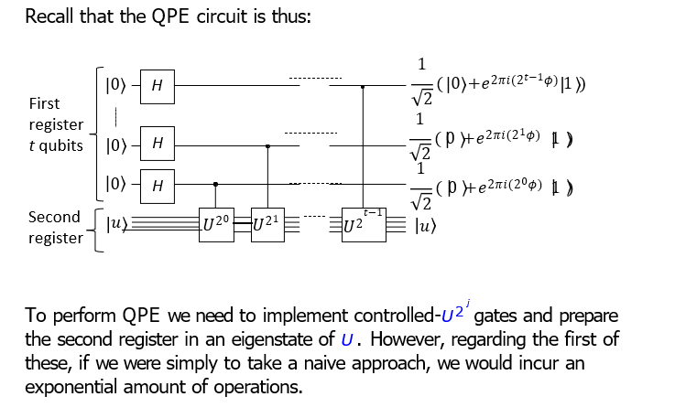
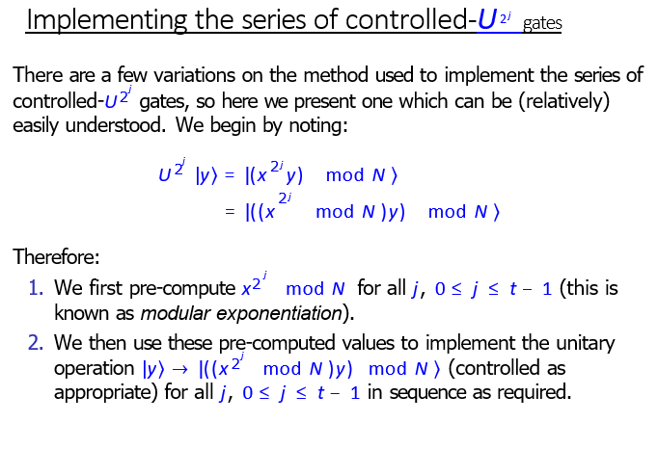
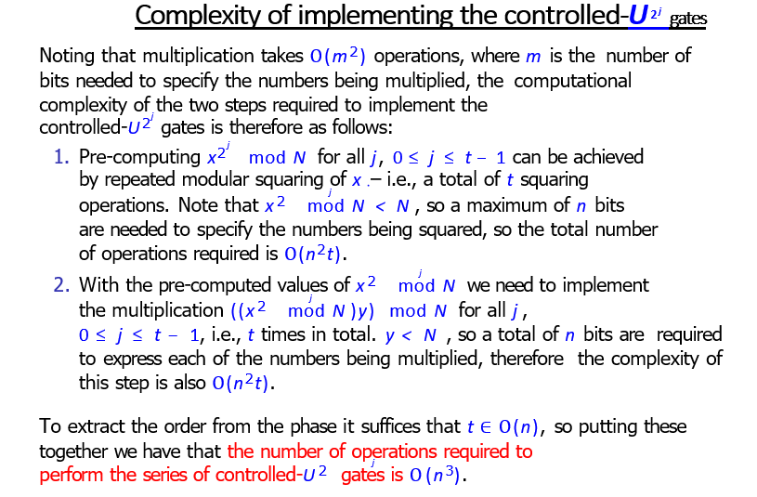

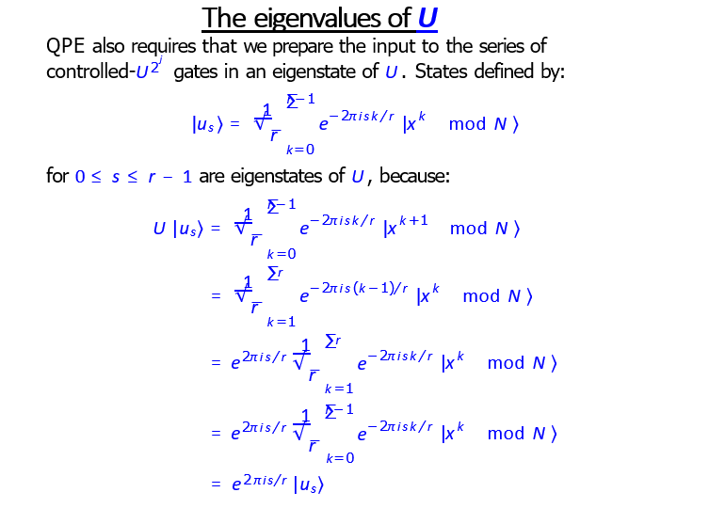
Reduction of factoring to order-finding :
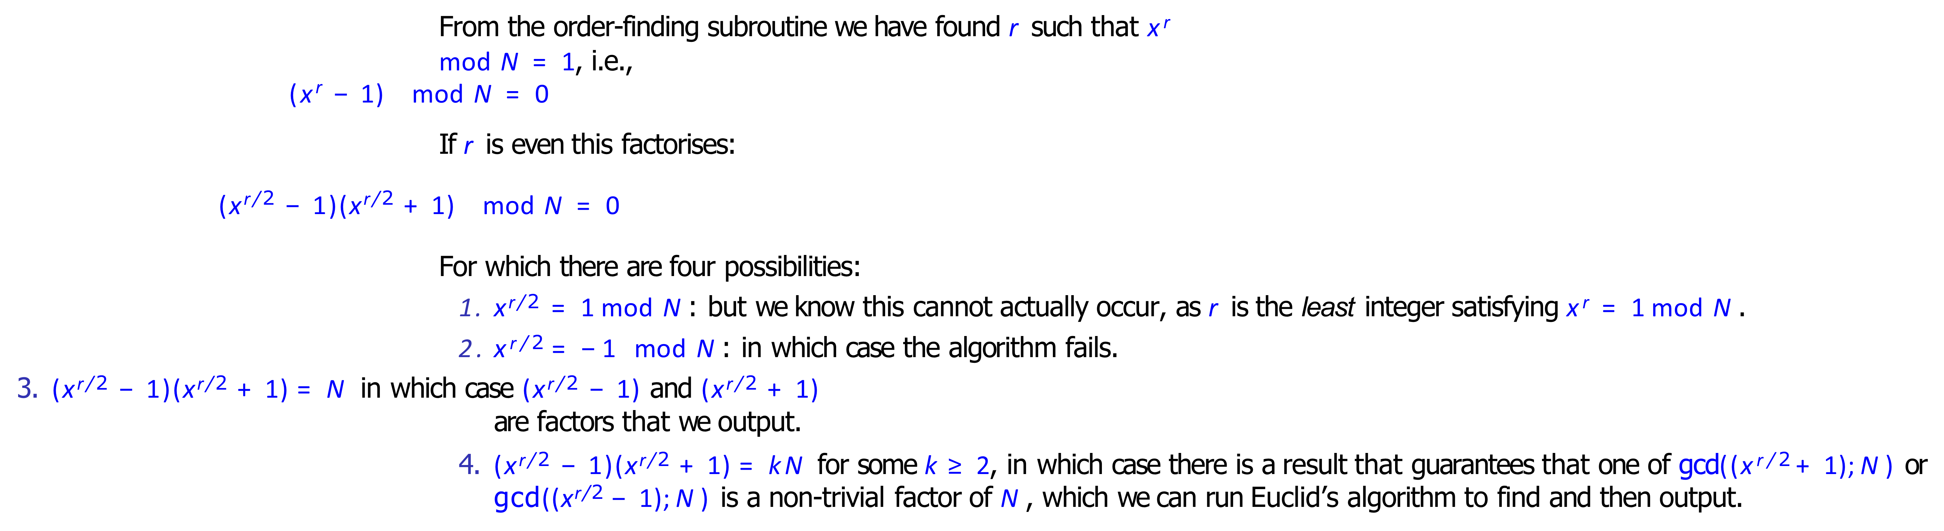

Shor’s algorithm: success probability :

A single run of Shor’s algorithm only returns a factor with a certain probability. In particular:
The order-finding subroutine could return even r.
The order-finding subroutine could return r such that x ^{r/2} = −1 mod N .
It is possible that the classical post-processing required to extract the order from the phase can fail.

The probability that r is such that neither of the first two occur is at least one half. The probability that the order-finding subroutine is such that the classical post-processing correctly returns the order is at least 1 − ϵ for some constant ϵ.
Therefore a single run of Shor’s algorithm correctly returns a factor with probability O(1), which is acceptable, as the expected number of iterations needed to find a factor does not grow with n.

General applications of the quantum Fourier transform- Period Finding:

The Quantum Fourier Transform is a versatile tool that finds applications in quantum algorithms, quantum simulations, error correction, quantum communication, and other quantum computing tasks. Its ability to encode and manipulate quantum states efficiently is at the heart of many quantum algorithms' success in solving complex problems faster than classical counterparts.

The Quantum Fourier Transform (QFT) has applications beyond just period-finding in Shor's algorithm. It is a fundamental operation in quantum computing that finds use in various areas, particularly those involving quantum algorithms that leverage interference patterns and superposition states. Here are some general applications of the Quantum Fourier Transform:
- Quantum Phase Estimation (QPE):
Quantum Phase Estimation is a powerful quantum algorithm that uses the Quantum Fourier Transform to estimate the eigenvalues of unitary operators. It is a key subroutine in various quantum algorithms, such as quantum simulations and factoring. QPE is used to extract information about the phase factor of eigenvectors, which has implications for solving linear algebraic problems efficiently.
- Quantum Simulations:
Quantum simulations involve modeling quantum systems on a quantum computer to study physical phenomena that are hard to simulate classically. The Quantum Fourier Transform is often used in quantum simulations to encode the time evolution of quantum systems, which allows researchers to study quantum dynamics and properties of materials.
- Quantum Search Algorithms:
Quantum search algorithms, like Grover's algorithm, are designed to search through unsorted databases more efficiently than classical algorithms. These algorithms make use of the Quantum Fourier Transform to amplify the probability of finding the correct solution while suppressing the probabilities of incorrect solutions. Grover's algorithm, in particular, employs the Quantum Fourier Transform to rotate the search space towards the target state.
- Quantum Error Correction:
Quantum error correction is essential for building reliable quantum computers. The Quantum Fourier Transform is used in various quantum error correction codes to measure and correct errors efficiently. Quantum error correction codes utilize the principles of quantum interference and superposition to protect quantum information from noise and decoherence.
- Quantum Chemistry and Quantum Machine Learning:
Quantum chemistry simulations and quantum machine learning applications often require the efficient manipulation of quantum states and operators. The Quantum Fourier Transform can be employed to encode and manipulate quantum data in these contexts, contributing to the solution of complex chemical and physical problems.
- Quantum Communication:
Quantum communication protocols, such as quantum key distribution, exploit the properties of quantum states to achieve secure and efficient communication. The Quantum Fourier Transform is sometimes used to generate entanglement and perform operations that underpin these protocols.
- Quantum Algorithms and Quantum Circuits:
The Quantum Fourier Transform is a key building block in various quantum algorithms and circuits beyond Shor's algorithm. It is often used for creating interference patterns that enhance the probability of obtaining the correct solution in various quantum computations.

General applications of the quantum Fourier transform- Discrete logarithms, The hidden subgroup problem :
The Quantum Fourier Transform (QFT) has significant applications beyond period-finding in Shor's algorithm. Two of these important applications are solving discrete logarithm problems and tackling the hidden subgroup problem, both of which have relevance in the field of quantum computing and cryptography:
- Discrete Logarithms:
The discrete logarithm problem is a foundational problem in number theory and cryptography. Given a prime number p, a primitive root g modulo p, and an integer y, the discrete logarithm problem involves finding the integer x such that g^{x} ≡ y(modp).
This problem is considered hard to solve classically, and its difficulty forms the basis for certain cryptographic protocols, including the Diffie-Hellman key exchange and variants.
Quantum algorithms that employ the Quantum Fourier Transform can provide an exponential speedup for solving the discrete logarithm problem. For example, the Quantum Discrete Logarithm Algorithm (QLD) uses the Quantum Fourier Transform to find the discrete logarithm more efficiently than classical algorithms. QLD has implications for breaking cryptographic schemes that rely on the discrete logarithm problem for security.
- Hidden Subgroup Problem:
The hidden subgroup problem is a computational problem that generalizes many problems in number theory and group theory. Given a function f : G→X, where G is a group and X is a set, the goal is to find a subgroup H of G such that f is constant on cosets of H or is a non-constant function on different cosets. The hidden subgroup problem is a fundamental problem in quantum algorithms and has applications in various fields, including cryptography and graph theory.
The Quantum Fourier Transform plays a crucial role in solving the hidden subgroup problem efficiently. Quantum algorithms like Simon's algorithm and the quantum phase estimation algorithm use the Quantum Fourier Transform to find a hidden subgroup of a function faster than classical algorithms. These algorithms have implications for solving problems like factoring and lattice-based cryptography.
In both cases, the Quantum Fourier Transform is utilized to amplify certain quantum states that encode information about the solution. This amplification is achieved through interference effects, where the Quantum Fourier Transform brings out the desired information by enhancing the probability amplitude of correct solutions and suppressing incorrect ones. These applications highlight the power of quantum algorithms in tackling problems that are intractable for classical computers.

